# **Maximise Insights – Homepage Website Content**

**Title:**

Building New Technologies to Transform Your Business

<https://muahmmadrizwan.github.io/insights/>

**Meta Description**

Find local web developers and a custom web development team at Maximise Insights. Our services offer you a chance to upgrade your online presence with innovative solutions.

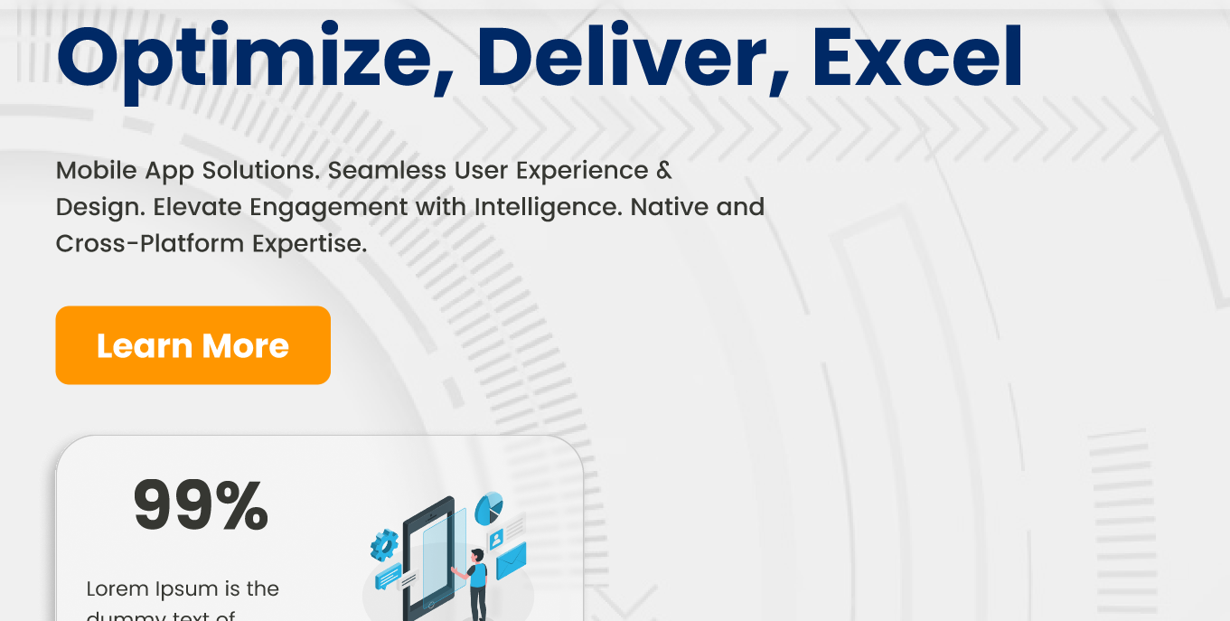

## **Dominate the Digital Landscape**

At Maximise Insights, our services are crafted to guarantee you don't just exist in the digital landscape – you dominate it. Discover the **best language for web development** with us as your trusted **front-end web development company**.

**99% Dedication, 100% Impact for Your Website Project Plan – Your Digital Revolution Starts Here!**

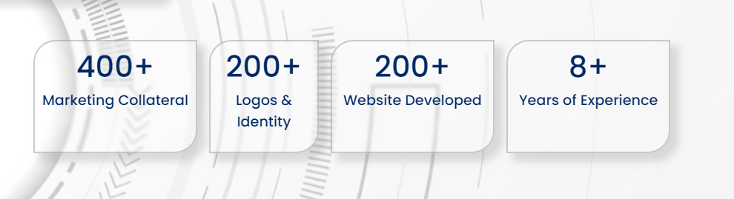

* ***1,500+ Digital Campaigns Sparking Success***
* ***200+ Tailored Solutions Redefining Industries***
* ***10,000+ Engaged Social Media Audiences***
* ***98% Client Satisfaction Across 300+ Projects***

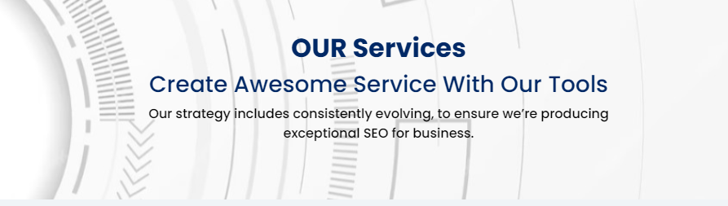

## **Our Services**

***Innovative Digital Solutions with a Customized Approach***

With a proven history of launching over 400 websites into the digital sphere, we bring a simplicity-first approach to every **development project**.

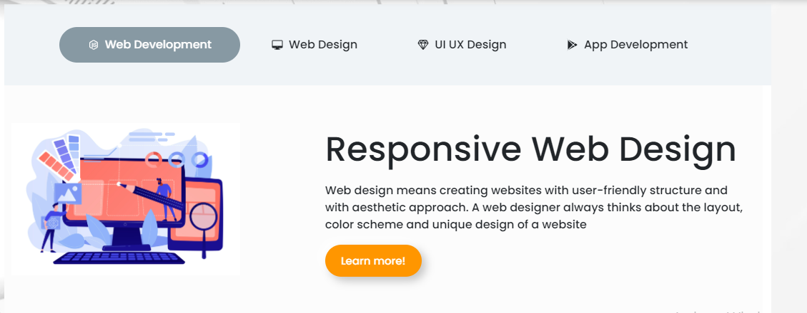

* **Web Development**

Take a digital leap with us. We excel in creating functional websites that flawlessly exhibit your brand, translating your ideas into a unique online identity.

* **Web Design**

Design a brand masterpiece online. With our **graphic design firm, we** integrate brand aesthetics with user-friendly interfaces, creating websites that captivate, inform, and convert.

* **UI/UX Design**

We concentrate on intuitive interfaces, placing user-centricity at the forefront to create websites that provide a smooth experience for your visitors.

* **App Development**

Have a vision for an application in mind? Our app development expertise turns your ideas into reality. From conceptualization to execution, let us help you develop user-friendly applications with the right functionalities.

* **Graphic Designing**

Explore our expertise in **graphic art** and boost your brand with a **visual designer** for a unique and captivating online identity. Whether you want a **simple design** that resonates with your brand philosophy or wish to stand out among other **graphic websites**, our **graphics design service** is dedicated **to** creating stunning and impactful designs.

* **Digital Marketing**

Maximise Insights offers tailored **digital marketing packages** for your business growth. Our approach goes beyond conventional strategies, encompassing **full-service marketing**, **technology marketing**, and **internet marketing** to amplify your online presence

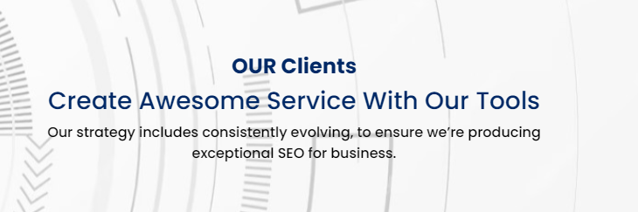

## **Brands We Have Served**

***Our Partnerships on Web Development Projects***

Meet the brands that have experienced success after handing over their **development project** to Maximise Insights.

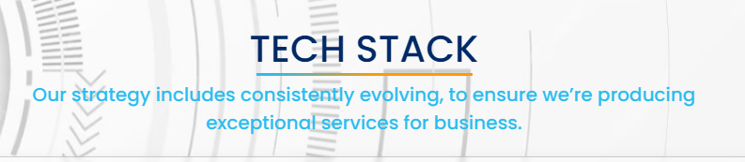

## **Explore Our Tech Stack Expertise**

From complex frameworks to cutting-edge technologies, our **services offer** a dynamic tech stack for unparalleled digital solutions.

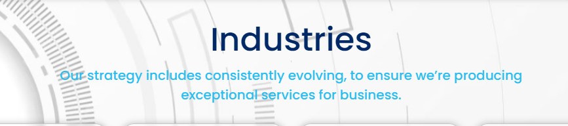

## **Industries We Transform**

Discover how the **award-winning development team** at Maximise Insights leverages years of expertise to empower multiple businesses.

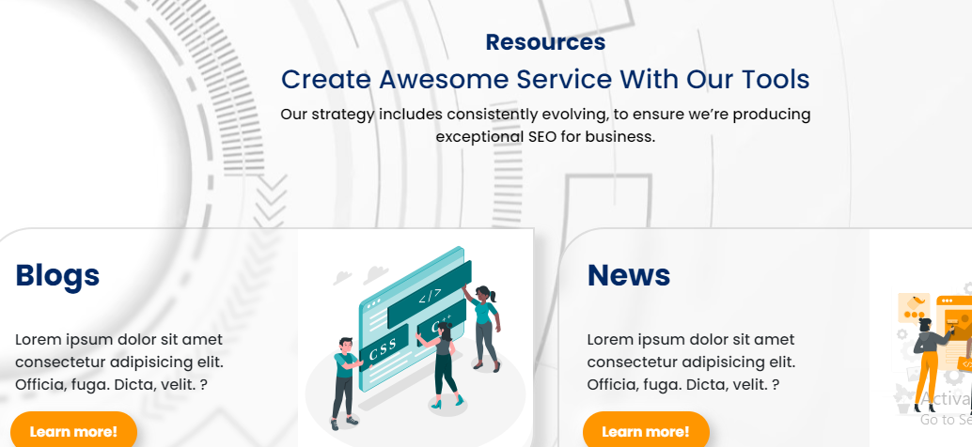

## **Maximise Insights Resources**

Explore our comprehensive resources to gain insights into the latest digital trends, industry best practices, and innovative solutions for your business.

***MaxInsightful Blogs***

Explore MaxInsightful Blogs for easy-to-understand insights, industry wisdom, and practical tips that help you understand complex ideas.

***MaxInsightful Newsroom***

Discover the latest happenings, partnerships, and innovations at Maximise Insights.

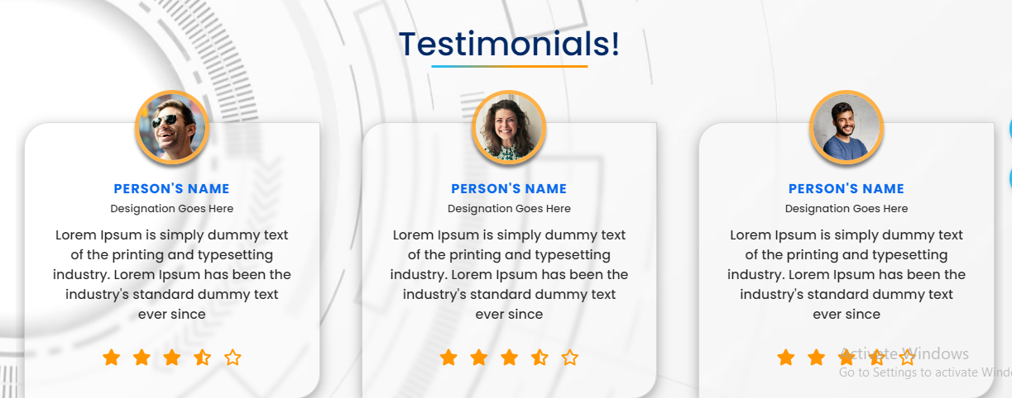

## **Real Stories, Real Success**

Here are some testimonials from our previous web development projects that left the clients satisfied with our services.